HOW DOES ONE VOTE IN CAMBRIDGE?

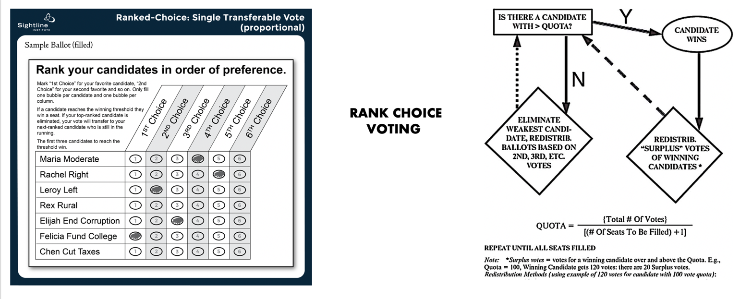

Short Summary:
- Your #1 vote counts the most, since this makes it easier for your preferred candidate to reach the necessary vote threshold to get elected and the quantity of #1 votes a candidate receives determines how quickly he or she will be eliminated from consideration.
- However, ALL your votes also count, so vote for as many candidates as you think would make good City Councillors or school committee members. This is because even if they don’t win, their votes may help your other, more preferred candidates, get elected.

What Kind of Voting System Does Cambridge Use? Cambridge employs a citywide “at-large” ranked choice voting form (also called proportional representation or PR). Under this system, a candidate for City Council or the School Committee must win a certain proportion of the votes cast (called the “quota”) to be elected.

How Does Our Voting System Work? In Cambridge voters pick as many candidates as they wish, ranking them in their preferred order (see top left graphic). Once the vote count starts, the #1 votes are counted first for each candidate. If any candidate has enough #1 votes to reach the quota on the first round, that candidate is automatically elected. If a candidate who is elected on the first round has more votes than the quota number, that candidate’s surplus votes go to the next choice among candidates who not yet been defeated, i.e. “continuing candidates” (elected or still in play). This is also true for the defeated candidates’ ballots.

Next the candidate with the fewest #1 votes is taken up by the tabulator; this candidate is eliminated from consideration and their # 2 votes are redistributed to the candidates receiving this candidate’s voters’ #2 choices. This process continues for the remaining candidates who have the fewest # 1 votes, with each in turn being eliminated, and their #2 votes are redistributed to other candidates if they are still in play, until there are no votes left to be redistributed, and all 9 City Councillor seats or all 6 School Committee seats are filled.

The tabulator’s vote count movement shifts from top to bottom to top again as suggested in the above right graphic. In 2021, it took 13 rounds of transfer votes until the final results were known. See the data here: http://rwinters.com/elections/Council2021-Official.pdf
What is the Quota? In brief, the quota is the fewest number of votes required to elect candidates to the number of seats to be filled. Each Cambridge election is different, so the total number of ballots cast varies, as does the quota number. To determine each year’s quota number, one looks at the total count of legitimate ballots cast that year, and then divides this number by the number of seats being filled plus 1 (9 for City Council plus 1 and 6 for School Committee plus 1). One then adds +1 to the number and if this is a fraction, it is rounded up.
For example, if 20,000 valid ballots are cast for City Council, one divides this number by 10 (9 seats + 1) to get 2,000; then 1 more is added to get a quota of 2,001. For the School Committee, one would divide by 7 (6 seats +1) to get 2,857.14 and rounded up to get a quota of 2,858. In 2017 each Council Candidate had to receive 2,001votes to win; a school committee member had to earn 2,858 votes to win. In a few cases, candidates win without reaching quota if they are still standing (still in play) once all the votes have been distributed.

Why do #1 Votes Count So Much? Candidates with the highest number of #1 votes at the outset (the first round) have a far better chance of winning a position on City Council or School Committee because they need fewer transfer votes (those marked #2, #3. #4 etc.). That is why all candidates ask for your #1 vote since it decreases their chances of being eliminated early in the process and increases their chances of being elected. In many elections only 1 person reaches quota the first round, so 8 of 9 City Council candidates need a sizable number of your #2, #3 and other votes to reach quota. Your #1 vote is the most important, but your other vote choices are critical too.

How many people should you vote for? Voters should rank as many candidates as they think would make good Councillors or School Committee members. Why? Because if one’s #1 choice candidate does not make the “cut” (quota), one’s votes for the #2 (#3, #4 choices etc.) likely will transfer to other candidates one supports, increasing the chances that they or your #1 choice will be elected. In some Cambridge elections just a few dozen “pass up” (transfer) votes determine the winner. And in some years, there can be 17+ rounds of vote redistributions before we know the final count. The more people you vote for, the more your candidates can benefit from other candidates you also support, and sometimes your 6th or 7th ranked choices can make a real difference by helping other viable choices reach quota and win.

Where Can I Find Out More Information? Answer: There are several good videos on this process: one locally made and one national.
- Ranked Choice Voting Video by former Councillor Jan Devereux (the “zoo” analogy): http://jandevereux.org/about/about-our-ranked-choice-voting-system/
- The Script of Jan Devereux’s Ranked Choice Voting Video Script (the “zoo” analogy):
http://jandevereux.org/about/about-our-ranked-choice-voting-system/
- Rolling Stone’s Ranked Choice Voting in 60 seconds video (ice cream analogy) https://youtu.be/5ZoFjaTSvQY
See also:
- http://rwinters.com/elections/supplement.htm
- https://fairvote.org/spotlight_cambridge/
- https://www.rcvresources.org/in-practice-cambridge-ma

Register to Vote (or Learn if you are Registered to Vote): www.vote.gov.com

See also: https://www.cambridgema.gov/Departments/electioncommission

Apply for a mail in/drop off Voting Ballot: https://www.sec.state.ma.us/MailInRequestWeb/MailInBallot.aspx

Date of In Person 2023 Voting in Cambridge: November 7.

